ECLIPSE® BIGLEAF HYDRANGEA:
MEET THE NEW DARK LEAF ROCK STAR
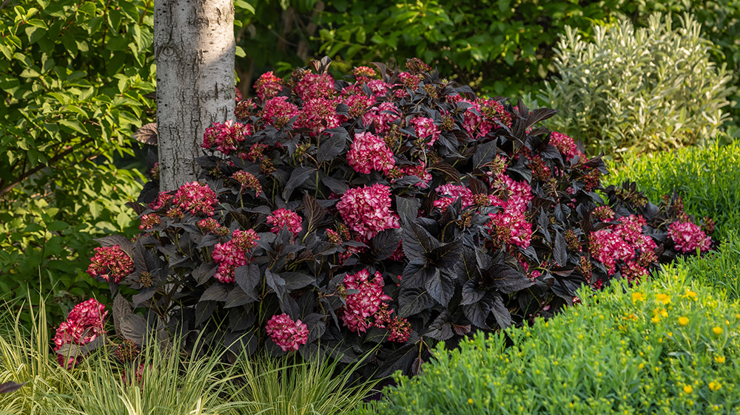
Meet Eclipse® Bigleaf Hydrangea, the first true dark-leaf mophead hydrangea, and the newest Rock Star to join the First Editions® collection. With dark purple, almost black leaves, Eclipse® is sure to make an impact in your garden all season long. This new dark-leaf hydrangea will change how you think about and use hydrangeas. Say goodbye to the old way of thinking about hydrangeas and say hello to an Eclipse® worth staring at!

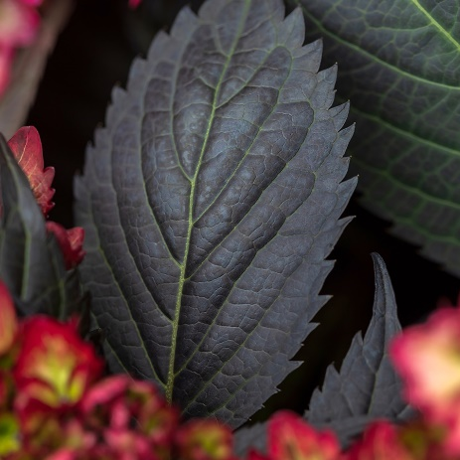

THE DARK LEAVES!
The dark leaves on Eclipse® are as impressive in the garden as they are in the plant world. Eclipse® is the first mophead hydrangea to have dark leaves that will come back just as dark next season. The team at First Editions® worked on Eclipse® for over eight years to select, trial, and test Eclipse® to ensure that was the case, even for warm climate gardeners where other dark leaf hydrangeas can start to go green. All the history and effort behind Eclipse® means you can confidently use this plant in your garden, knowing that you get to enjoy dark leaves year after year.
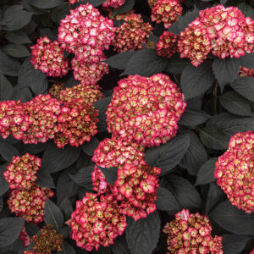

THE HYDRANGEA FLOWERS!
While the leaves are quite a sight, you can’t forget about the hydrangea flowers! Eclipse® has spectacular cranberry or amethyst-colored blooms that provide fantastic contrast to the dark leaves. Like other Hydrangea macrophylla, the color of the flowers depends on the soil pH. But in general, Eclipse® hydrangeas grown in alkaline soils will have cranberry flowers, while those grown in acidic soils will have amethyst flowers. Eclipse® is also a reblooming hydrangea, so you can enjoy a garden full of hydrangea blooms throughout the season.

ECLIPSE®: IT’S ALL IN THE DETAILS
Mature Height: 3-5 feet
Mature Width: 3-5 feet
Sun Exposure: Morning sun, afternoon shade
Hardiness Zone: 5-9
Heat Zone: 9
Shape: Mounded
Leaf Color: Dark purple, almost black
Bloom Color: Cranberry blooms or amethyst blooms, depending on the soil pH

