Feelin’ Blue Deodar Cedar

Cedrus deodara
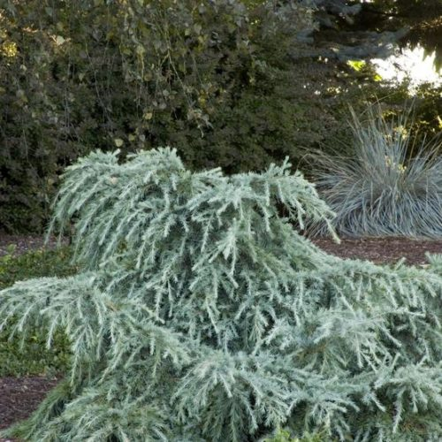
A unique dwarf spreading evergreen with bluish-green needles. The lowest of the dwarf Cedars, this selection rarely develops a leader. We have evidenced winter hardiness in some USDA Zone 6 areas, with good winter protection provided.
Noteworthy Characteristics Use this bright blue conifer in shrub borders for an injection of carefree cool color. It's a natural for rock gardens nestled into landscape boulders. Irregular form fits nicely into woodland gardens that need relief from too much green. Spot into wild gardens among naturalistic compositions of native shrubs and prairie grasses. Low profile growth makes this creeping shrub a perfect groundcover on banks and slopes or cascading off raised planter edges and retaining walls. A truly eye-catching candidate planted in well chosen, elegant Asian containers.
- Plant Height:1 to 3 feet
- Plant Width:6 to 10 feet
- Zones:7, 8, 9
- Foliage Color:Bluish-green
- Light:Full Sun

