PUS CONTORTA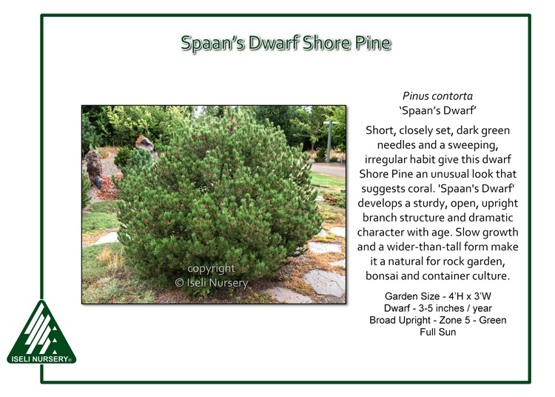
Spaan’s Dwarf Shore Pine
Short, closely set, dark green needles and a sweeping, irregular habit give this dwarf Shore Pine an unusual look that suggests coral. Named for the nurseryman who found it in Washington state, Pinus contorta ‘Spaan’s Dwarf’ develops a sturdy, open, upright branch structure and dramatic character with age. Slow growth and a wider-than-tall form make it a natural for rock garden, bonsai and container culture.

Garden Size: 4’H x 3’W
Dwarf: 3-5″/year
Broad Upright
Zone 5
Green
Conifer
Full Sun

