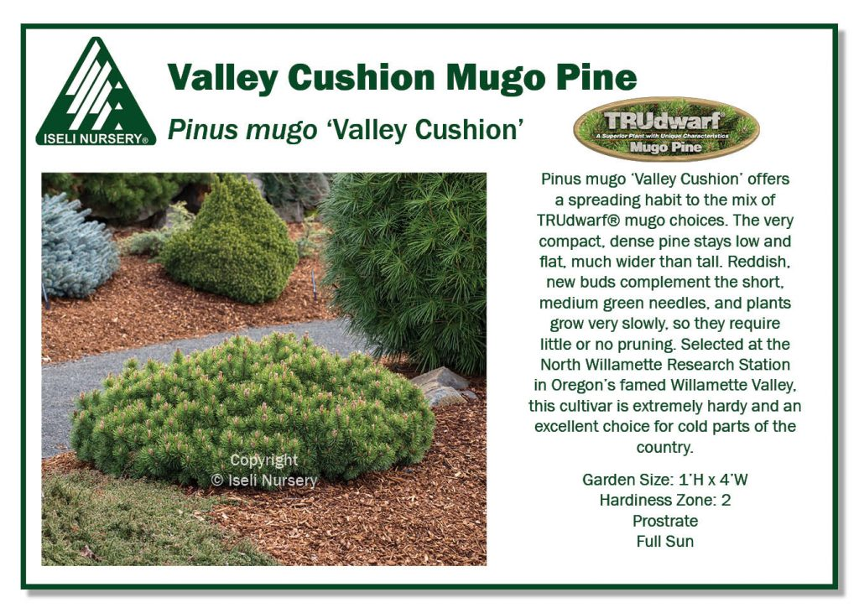

Valley Cushion TRUdwarf® Mugo Pine
Pinus mugo ‘Valley Cushion’ offers a spreading habit to the mix of TRUdwarf® mugo choices. The very compact, dense pine stays low and flat, much wider than tall. Reddish, new buds complement the short, medium green needles, and plants grow very slowly, so they require little or no pruning. Selected at the North Willamette Research Station in Oregon’s famed Willamette Valley, this cultivar is extremely hardy and an excellent choice for cold parts of the country.
Pinus mugo ‘Valley Cushion’
- Garden Size: 1’H x 4’W
- Growth Rate: 3-5″/year
- Hardiness Zone: 2
- Prostrate
- Full Sun
- Green Needle

